BIOINFORMATICS
INTERNSHIP REPORT

Submitted by
NOOHI KHAN
Btech Biotechnology
NOIDA INSTITUTE OF ENGINEERING & TECHNOLOGY
Submitted to
CODE ALPHA

Date : 15th June 2026


TABLE OF CONTENT
- Task 1: DNA/Protein Sequence Analysis Using BLAST.
- Task 2 : Multiple Sequence Alignment (MSA)
- Task 3 : Protein Structure Prediction
- References

TASK 1: DNA/ Protein Sequences Using BLAST
Aim
To identify homologous protein sequences of human myoglobin using BLAST.
Database Used
- UniProt
- NCBI BLAST
Procedure
- Selected Human Myoglobin (MYG_HUMAN) from UniProt.
- Obtained the protein FASTA sequence.
- Submitted the sequences to NCBI BLASTP.
- Performed BLAST using default parameters .
- Observe the homologous sequences and alignment result.
Results
▪️ Protein : Myoglobin(Human)
▪️ Query Length: 154 amino acids.
▪️ Top Match : Myoglobin isoform X1 (Nomascus leucogenys).
▪️ Identity : 153/154 (99%)
▪️ Positives : 153/154 (99%)
▪️ Gaps : 0/154 (0%)
▪️ E-value : 1e-106
▪️ Score : 313 bits
Interpretation
The BLAST analysis showed a very high similarity (99% identity) between the human myoglobin protein and homologous proteins in related species. The extremely low E-value indicates that this match is highly significant and not due to chance.

Screenshot
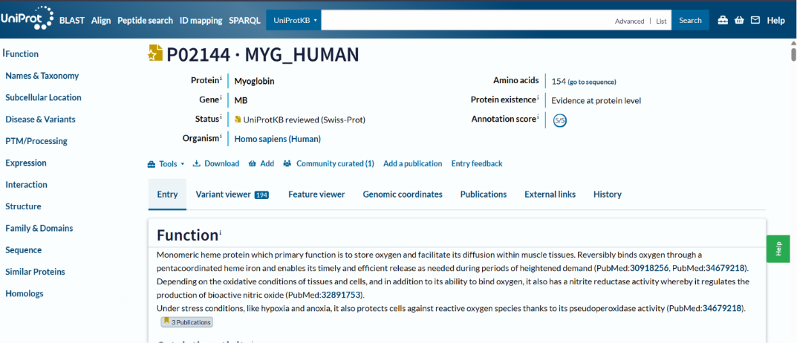
Fig 1. UniProt page of Human Myoglobin
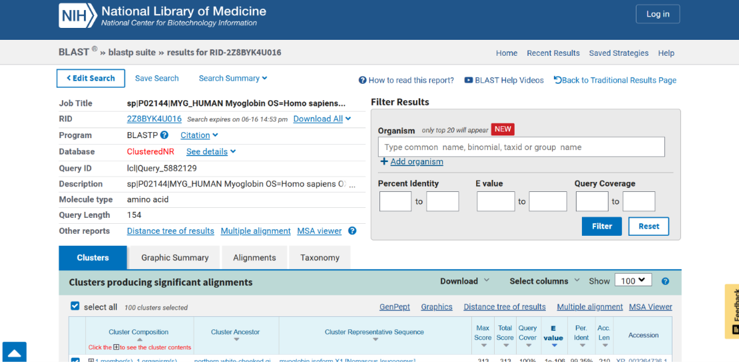
Fig 2. BLASTP result page.
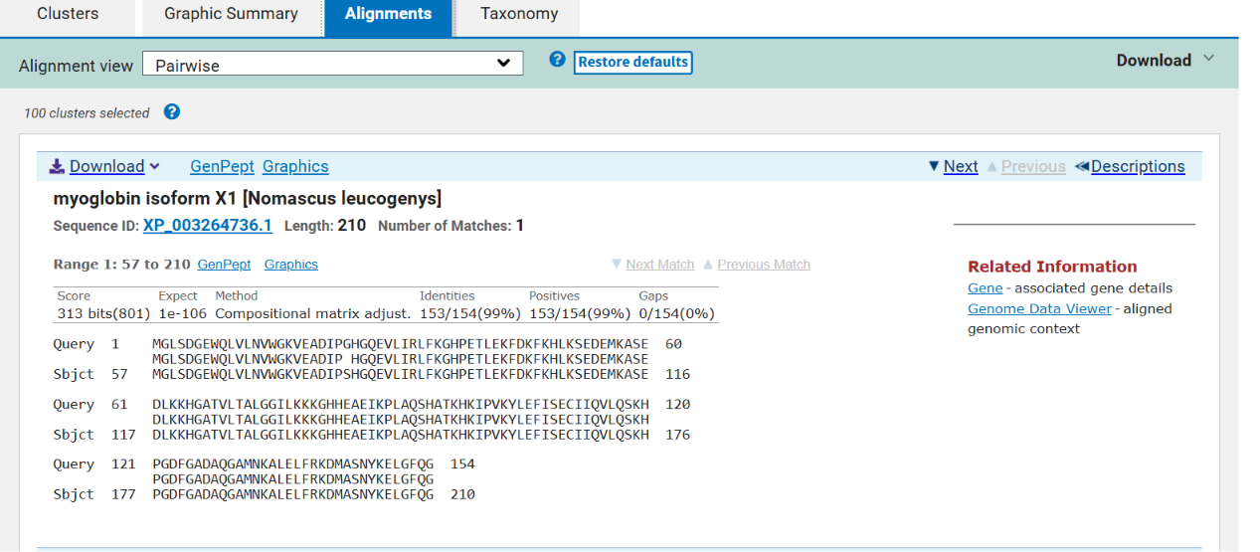
Fig 3. BLAST Alignment page.

Conclusion
The BLAST analysis successfully identified homologous protein sequences. Human myoglobin is highly conserved among related species, indicating its important biological function.

TASK 2 : Multiple Sequences Alignment (MSA)
Aim :
To perform Multiple Sequence Alignment (MSA) of five Myoglobin protein sequences using Clustal Omega and identify conserved regions and sequence similarity.
Introduction
Multiple Sequence Alignment (MSA) is a bioinformatics technique used to compare three or more biological sequences. It helps identify conserved regions, evolutionary relationships, and functional similarities among proteins. In this task, five Myoglobin protein sequences from related species were aligned using Clustal Omega.
Tool Used
- UniProt
- Clustal Omega (EMBL-EBI)
Protein Sequences Selected
1. MYG_HUMAN (Human)
2. MYG_PANTR (Chimpanzee)
3. MYG_GORGO (Gorilla)
4. MYG_PONPY (Orangutan)
5. MYG_HYLAG (Gibbon)

Procedure
1. Selected five Myoglobin protein sequences from UniProt.
2. Collected their FASTA sequences.
3. Opened the Clustal Omega tool.
4. Pasted all five sequences into the input box.
5. Ran the Multiple Sequence Alignment.
6. Examined the alignment and identified conserved regions.
7. Observed the guide tree and phylogenetic tree.

Results
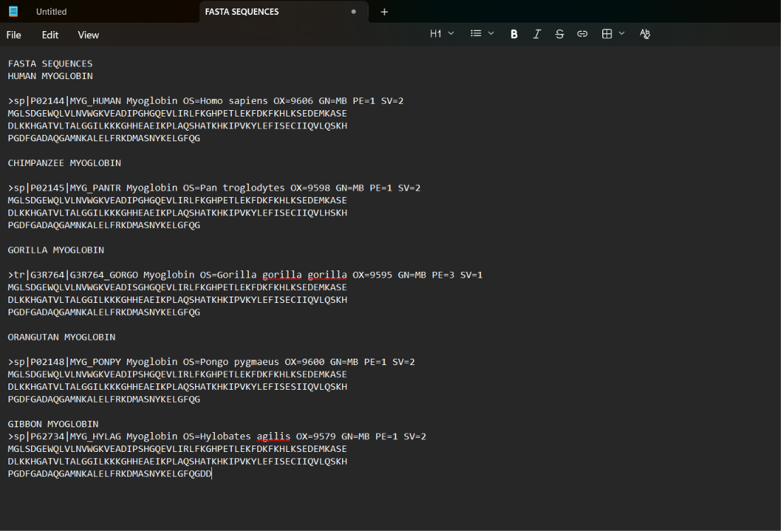
Fig 1 : Fasta Sequences of selected 5 Protein
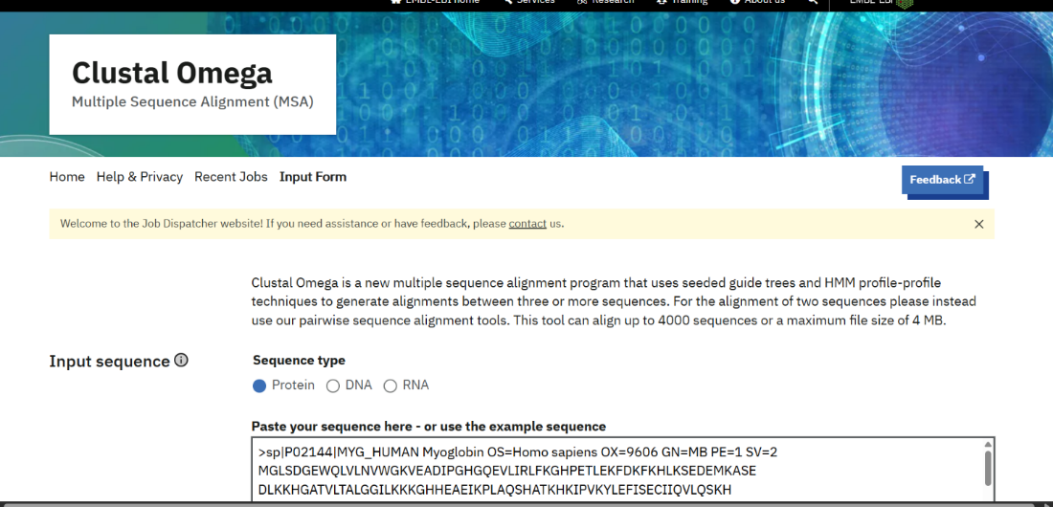
Fig 2 : Input FASTA sequences of selected Myoglobin proteins for MSA.
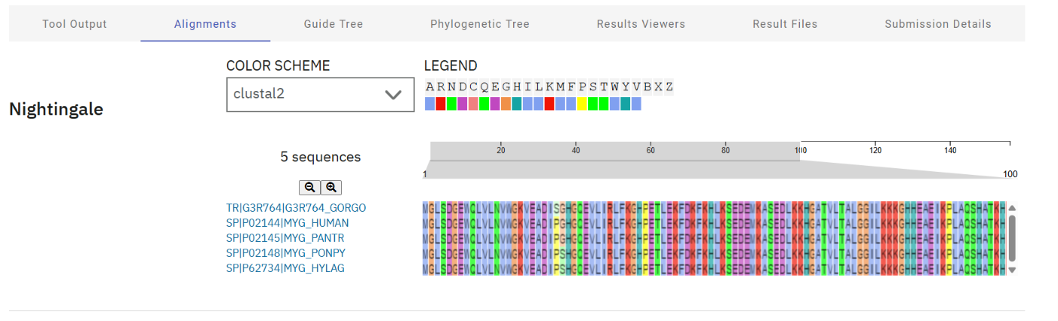
Fig 3 : Clustal Omega Alignment showing conserved amino acid regions among selected proteins.

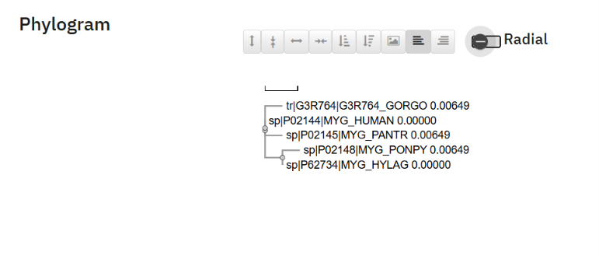
Fig 3 : Phylogenetic Tree
Interpretation
The alignment demonstrates that Myoglobin proteins are highly conserved across related species. Conserved regions indicate important functional and structural roles of the protein. The phylogenetic analysis suggests that these proteins share a common evolutionary origin.
Conclusion
Multiple Sequence Alignment using Clustal Omega successfully identified conserved regions among five Myoglobin proteins. The high similarity confirms that these proteins belong to the same family and perform similar biological functions.

TASK 3 : Protein Structure Prediction
Aim
To predict and visualize the three-dimensional structure of Human Myoglobin using the AlphaFold Protein Structure Database.
Introduction
Protein structure prediction is an important area of bioinformatics that helps understand protein function and biological mechanisms. AlphaFold, developed by DeepMind, predicts protein structures with high accuracy using artificial intelligence techniques.
Tool Used
AlphaFold Protein Structure Database
UniProt Database
Protein Selected
Protein Name: Myoglobin
Gene: MB
UniProt ID: P02144
Organism: Homo sapiens (Human)
Procedure
- Selected Human Myoglobin from UniProt.
- Searched the protein using its UniProt ID (P02144) in AlphaFold.
- Opened the predicted structure entry.
- Visualized the 3D protein structure.
- Examined model confidence scores and structural features.
- Captured screenshots of the results.

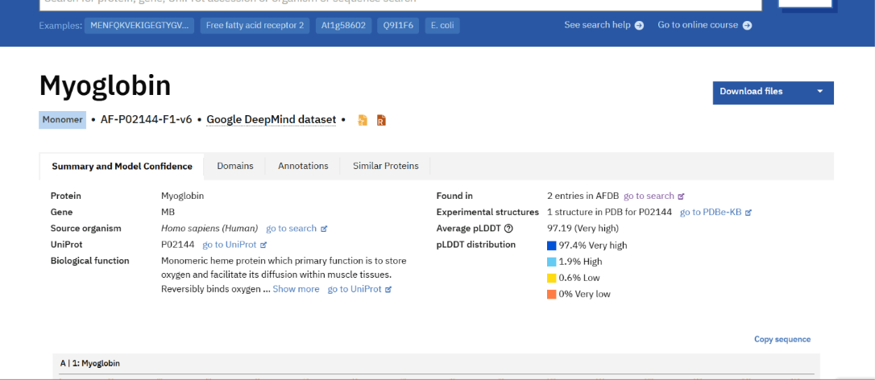

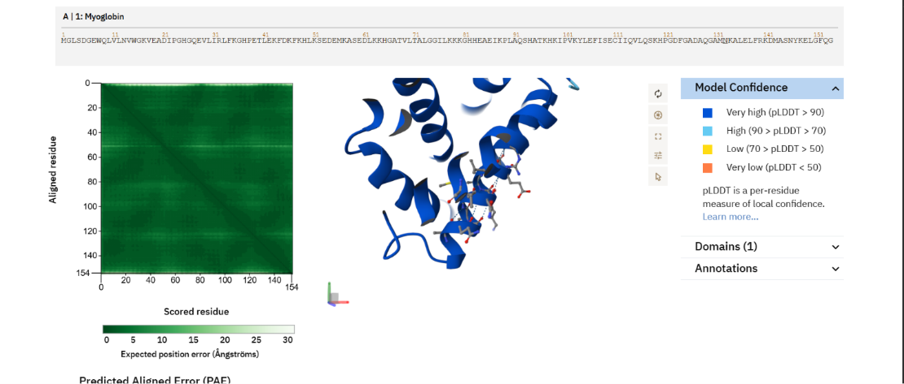

Key Findings
Average pLDDT Score: 97.19
Confidence Level: Very High
Very High Confidence Residues: 97.4%
High Confidence Residues: 1.9%
Low Confidence Residues: 0.6%
Very Low Confidence Residues: 0%
Conclusion
The AlphaFold prediction successfully generated a reliable three-dimensional structure of Human Myoglobin. The very high pLDDT score indicates that the predicted structure is highly accurate and suitable for structural and functional studies.

REFERENCES
- UniProt Consortium. UniProt: the Universal Protein Knowledgebase. Available at: https://www.uniprot.org⁠�

- National Center for Biotechnology Information (NCBI). BLAST: Basic Local Alignment Search Tool. Available at: https://blast.ncbi.nlm.nih.gov⁠�

- EMBL-European Bioinformatics Institute (EMBL-EBI). Clustal Omega Multiple Sequence Alignment Tool. Available at: https://www.ebi.ac.uk/Tools/msa/clustalo/⁠�

- AlphaFold Protein Structure Database. Protein Structure Prediction Database. Available at: https://alphafold.ebi.ac.uk⁠�

- The National Library of Medicine (NLM), National Center for Biotechnology Information (NCBI). Available at: https://www.ncbi.nlm.nih.gov⁠

